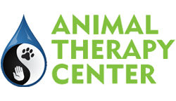
MEDIA CONSENT FORM

Client Name: ___________________________ Pet Name: _________________________________

I hereby attest that I am at least 18 years of age.

I hereby grant to the Animal Therapy Center and their staff permission to use my pet's name, biography, photography, or performing persona for marketing, educational materials, print, broadcast or distribution in any format of media know now or in the future.

Further, I release the Animal Therapy Center and their staff from any claim or cause of action for invasion of privacy or any similar right.

I understand and agree that there will be no compensation or attribution.

I understand that this consent is effective until such time as I revoke it in writing and provide a copy of the revocation to the Animal Therapy Center.

□ I do not grant permission for the above

Comments: ________________________________________________________________________________

__________________________________________________________________________________________

___________________________________ _________________ __________________
Signature Date Account #

