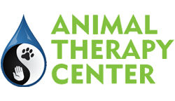
NEW CLIENT SURVEY
Date: _____________________
Client: __________________________________________ Pet: ________________________________
Thank you for choosing the Animal Therapy Center for your pet’s rehabilitation and integrative medicine needs. We appreciate your providing the following information so we may improve our staff scheduling and serve you better. This is for survey purposes only.
How did you hear about us?
□ Referred/recommended by my primary veterinarian
If so, which doctor or practice referred you to us? ___________________________________________
□ The Animal Therapy Center website/internet search
□ Saw a brochure/flyer/advertisement
□ Other: _________________________________________________________________________________
Which of our services are you interested in pursuing for your pet?
□ Rehabilitation therapy
□ Integrative medicine/acupuncture
□ Recreational swimming (for healthy pets with no medical conditions)
□ Other: _________________________________________________________________________________
What condition(s) does your pet suffer from (if applicable)?
__________________________________________________________________________________________
__________________________________________________________________________________________

